Emilio M. Bruna1,2,3, María Uriarte4, Maria Rosa Darrigo3, Paulo Rubim3, Cristiane F. Jurinitz3, Eric R. Scott1, Osmaildo Ferreira da Silva3, & W. John Kress5

1 Department of Wildlife Ecology and Conservation, University of Florida, PO Box 110430, Gainesville, FL 32611-0430, USA

2 Center for Latin American Studies, University of Florida, PO Box 115530, Gainesville, FL 32611-5530, USA

3 Biological Dynamics of Forest Fragments Project, INPA-PDBFF, CP 478, Manaus, AM 69011-970, Brazil

4 Department of Ecology, Evolution and Environmental Biology, Columbia University, 1200 Amsterdam Ave., New York, New York 10027, USA

5 Department of Botany, National Museum of Natural History, PO Box 37012, Smithsonian Institution, PO Box 37012, Washington DC, USA

*Corresponding author*: Emilio M. Bruna ([embruna@ufl.edu](mailto:embruna@ufl.edu))

*Open Research Statement*: The data described here are available as Supporting Information at [ESA *url to be added*] and have been archived at the Dryad Digital Repository [*url to be added*]. The version of the code used to review, correct, and prepare this archive is available at Zenodo [*url to be added*]. The code used to prepare this manuscript, including statistical summaries reported in the text, tables, and figures, has also been archived at Zenodo [*url to be added*]. Post-publication updates to code and the data sets, along with other project-related information, can be found in the HDP Github Repository (<https://github.com/BrunaLab/HeliconiaSurveys>). ***To be deleted following peer review:*** Code for data management and all statistics/figures/tables presented in the manuscript is available for peer review at <https://github.com/BrunaLab/HeliconiaSurveys> (data management) and <https://github.com/BrunaLab/Bruna_etal_HeliconiaDataPaper> (manuscript).

Abstract

*METADATA FOR:*  
**Demography of the understory herb *Heliconia acuminata* (Heliconiaceae) in an experimentally fragmented tropical landscape**

## NULL

# METADATA

**I. CLASS I. Data Set Descriptors**

**A. Data set identity:** Demographic data from populations of the understory herb *Heliconia acuminata* (Heliconiaceae) in an experimentally fragmented tropical landscape (1998-2009).

**B. Data set identification code:**

1. Data set File 1: HDP_plots.csv
2. Data set File 2: HDP_survey.csv

**C. Data set description:**

1. **Originators:** Emilio M. Bruna, Department of Wildlife Ecology and Conservation, University of Florida, PO Box 110430, Gainesville, FL 32611-0430, USA and Center for Latin American Studies, University of Florida, PO Box 115530, Gainesville, FL 32611, USA.
2. **Abstract:** Habitat fragmentation remains a major focus of research by ecologists decades after being put forward as a threat to the integrity of ecosystems. While studies have documented myriad biotic changes in fragmented landscapes, including the local extinction of species from fragments, the demographic mechanisms underlying these extinctions are rarely known. However, many of them – especially in lowland tropical forests – are thought to be driven by one of two mechanisms: (1) reduced recruitment in fragments resulting from changes in the diversity or abundance of pollinators and seed dispersers or (2) increased rates of individual mortality in fragments due to dramatically altered abiotic conditions, especially near fragment edges. Unfortunately, there have been few tests of these potential mechanisms due to the paucity of long-term and comprehensive demographic data collected in both forest fragments and continuous forest sites. Here we report 11 years (1998-2009) of demographic data from populations of the Amazonian understory herb *Heliconia acuminata* (LC Rich.) found at Brazil’s Biological Dynamics of Forest Fragments Project (BDFFP). The resulting data set comprises >66000 plantyear records of 8586 plants, including 3464 seedlings that became established after the initial census. Seven populations were in experimentally isolated fragments (one in each of four 1-ha fragments and one in each of three 10-ha fragments), with the remaining six populations in continuous forest. Each population was in a m permanent plot, with the distance between plots ranging from 500 m-60 km. The plants in each plot were censused annually, at which time we recorded, identified, marked, and measured new seedlings, identified any previously marked plants that died, and recorded the size of surviving individuals. Each plot was also surveyed 4-5 times during the flowering season to identify reproductive plants and record the number of inflorescences each produced. These data have been used to investigate topics ranging from the way fragmentation-related reductions in germination influence population dynamics to statistical methods for analyzing reproductive rates. This breadth of prior use reflects the value of these data to future researchers. In addition to analyses of plant responses to habitat fragmentation, these data can be used to address fundamental questions in plant demography, the evolutionary ecology of tropical plants, and for developing and testing demographic models and tools. Though we welcome opportunities to collaborate with interested users, there are no restrictions on the use this data set. However, we do request that those using the data for teaching or research inform us of how they are doing so and cite this paper and the data archive when appropriate. Any publication using the data must also include a BDFFP Technical Series Number in the Acknowledgments. Authors can request this series number upon the acceptance of their article by contacting the BDFFP’s Scientific Coordinator or E. M. Bruna.

**D. Key words:** Amazon, Brazil, deforestation, demography, edge effects, flowering, forest fragments, habitat fragmentation, integral projection models, matrix models, population dynamics, vital rates.

**CLASS II. RESEARCH ORIGIN DESCRIPTORS**

**A. Overall project description:**

1. **Identity:** The *Heliconia* Demography Project
2. **Originators:** Emilio M. Bruna, W. John Kress, and María Uriarte
3. **Period of study:** 1998-2009
4. **Objectives:** Habitat fragmentation remains a major focus of research by ecologists (Didham et al. 2012, Haddad et al. 2015, Brudvig et al. 2017, Resasco et al. 2017, Fletcher et al. 2018) decades after it was first put forward as a threat to the integrity of ecosystems (Harris 1984, Wilcove et al. 1986). Studies have documented myriad biotic changes in fragmented landscapes, including the local extinction of species from fragments (Harrison and Bruna 1999, Laurance et al. 2011). The demographic mechanisms underlying these extinctions are rarely known (Bruna et al. 2009). However, many of them – especially in lowland tropical forests – are thought to be driven by one of two mechanisms: (1) reduced recruitment in fragments resulting from changes in the diversity or abundance of specialized pollinators and seed dispersers (Murcia 1996, Silva and Tabarelli 2000), or (2) increased rates of individual mortality in fragments (Laurance et al. 1998, Zartman et al. 2015) due to dramatically altered abiotic conditions, especially near fragment edges (reviewed in Broadbent et al. 2008). Unfortunately, tests of these potential mechanisms remain limited due to the paucity of long-term demographic data collected in both forest fragments and continuous forest sites (Bruna et al. 2009).

Most studies investigating the effects of forest fragmentation on tropical plants focus on trees (Cordeiro et al. 2009, Jurinitz et al. 2013, Zambrano and Salguero-Gómez 2014), in part because they are major reservoirs of carbon (Slik et al. 2010, Lasky et al. 2014). However, herbaceous species can comprise up to 30% of the plant species in lowland tropical forests (Gentry and Emmons 1987, Ribeiro et al. 2010, Iannone and Vargas 2022, Spicer et al. 2022), where they are habitat and food for myriad animal taxa as well as economically and culturally important non-timber forest products (Nakazono et al. 2004, Athayde et al. 2006). Despite their biocultural importance, however, the way in which habitat fragmentation and other global change phenomena influences the population dynamics of tropical understory plants remains conspicuously understudied (Bruna et al. 2009).

The *Heliconia* Demography Project (HDP) was established to address the lack of data on the demography of understory plants in fragmented tropical landscapes. The core of the HDP is annual censuses of thirteen populations of *Heliconia acuminata* located in either continuous forest or experimentally isolated forest fragments at Brazil’s Biological Dynamiocs of Forest Fragments Project (Laurance et al. 2011) The primary purpose behind their initial collection was to parameterize size-structured demographic models (Caswell 2000, Ellner and Rees 2006) with which to (1) compare the demography and population dynamics of *H. acuminata* populations in fragments and continuous forest, and (2) test the hypothesis that reductions in seedling establishment in forest fragments would lead to population declines. Simulations suggested extreme reductions in recruitment were necessary for population declines (Bruna 2003), and empirical estimates of seedling establishment in fragments were frequently below these thresholds (Bruna 2002). Other studies demonstrated that the growth rates of plants in fragments, where abiotic conditions are often(Broadbent et al. 2008) severely altered, are much lower than in continuous forest (Bruna et al. 2002). Chronically reduced growth (Gagnon et al. 2011), especially of large plants, is a primary contributor to lower population growth rates in forest fragments (Bruna and Oli 2005). More recent projects using the data set described have has, for example, assessed the effects of local environmental conditions, disperser diversity, and disperser behavior on safe-site vs. seed-limitation (Uriarte et al. 2010, 2011), quantified population genetic structure (Côrtes et al. 2013), and compared statistical methods for modeling reproductive rates (Brooks et al. 2019).

1. **Abstract:** Habitat fragmentation remains a major focus of research by ecologists decades after being put forward as a threat to the integrity of ecosystems. While studies have documented myriad biotic changes in fragmented landscapes, including the local extinction of species from fragments, the demographic mechanisms underlying these extinctions are rarely known. However, many of them – especially in lowland tropical forests – are thought to be driven by one of two mechanisms: (1) reduced recruitment in fragments resulting from changes in the diversity or abundance of pollinators and seed dispersers or (2) increased rates of individual mortality in fragments due to dramatically altered abiotic conditions, especially near fragment edges. Unfortunately, there have been few tests of these potential mechanisms due to the paucity of long-term and comprehensive demographic data collected in both forest fragments and continuous forest sites. Here we report 11 years (1998-2009) of demographic data from populations of the Amazonian understory herb *Heliconia acuminata* (LC Rich.) found at Brazil’s Biological Dynamics of Forest Fragments Project (BDFFP). The resulting data set comprises >66000 plantyear records of 8586 plants, including 3464 seedlings that became established after the initial census. Seven populations were in experimentally isolated fragments (one in each of four 1-ha fragments and one in each of three 10-ha fragments), with the remaining six populations in continuous forest. Each population was in a m permanent plot, with the distance between plots ranging from 500 m-60 km. The plants in each plot were censused annually, at which time we recorded, identified, marked, and measured new seedlings, identified any previously marked plants that died, and recorded the size of surviving individuals. Each plot was also surveyed 4-5 times during the flowering season to identify reproductive plants and record the number of inflorescences each produced. These data have been used to investigate topics ranging from the way fragmentation-related reductions in germination influence population dynamics to statistical methods for analyzing reproductive rates. This breadth of prior use reflects the value of these data to future researchers. In addition to analyses of plant responses to habitat fragmentation, these data can be used to address fundamental questions in plant demography, the evolutionary ecology of tropical plants, and for developing and testing demographic models and tools. Though we welcome opportunities to collaborate with interested users, there are no restrictions on the use this data set. However, we do request that those using the data for teaching or research inform us of how they are doing so and cite this paper and the data archive when appropriate. Any publication using the data must also include a BDFFP Technical Series Number in the Acknowledgments. Authors can request this series number upon the acceptance of their article by contacting the BDFFP’s Scientific Coordinator or E. M. Bruna.
2. **Sources of funding:** The initial establishment of plots and the 1998-2002 surveys were supported by grants to E. M. Bruna from the Smithsonian Institution (Graduate Student Research Award), the University of California, Davis (Center for Population Biology Graduate Research Grant, M. E. Mathias Graduate Research Grant), the Biological Dynamics of Forest Fragments Project (Graduate Student Logistics Grant), the National Science Foundation (Dissertation Improvement Grant INT 98-06351), and the Ford Foundation (Dissertation Year Fellowship). The 2001-2005 surveys were supported a grant from the National Science Foundation to E. M. Bruna (Research Starter Grant DEB-0309819). The 2006-2009 surveys were supported by grants from the National Science Foundation to E. M. Bruna (DEB-0614149) and María Uriarte (DEB-0614339). Subsequent analyses and the preparation of these data for archiving were supported by the National Science Foundation (DEB-1948607).

**B. Subproject description**

1. **Site description**
2. **Site type:** Lowland tropical forest
3. **Geography:** The data were collected at the Biological Dynamics of Forest Fragments Project (BDFFP, 2°30’S, 60°W), a 1000-km mosaic of lowland forest, forest fragments, secondary forests, and pastures located approximately 70 km north of Manaus, Amazonas, Brazil (Fig. 1).
4. **Habitat:** The BDFFP is dominated by tropical evergreen lowland forest (i.e., ‘tropical moist forest’, *sensu* Holdridge (1967). The forest canopy at the sites is ~35–40 m tall, with emergent trees of up to ~45 m (Rankin-de-Mérona et al. 1992). The tree community at the BDFFP is highly diverse: ~1300 species total (Laurance 2001), with as many as 280 tree species ha $​^{−}$ $​^{1}$ (Oliveira and Mori 1999). The understory is dominated by stemless palms (Scariot 1999). All HDP plots are located in *terra-firme* (i.e., non-flooded) forest and none are bisected by streams.
5. **Geology:** Soils in the sites are nutrient-poor xanthic ferralsols, known as yellow latosols in the Brazilian soil classification system. Despite their high clay content they have poor water-retention capacity (Fearnside and Leal-Filho 2001). The often rugged topography at the BDFFP ranges in elevation from 50-150 m elevation (Gascon and Bierregaard 2001).
6. **Watersheds:** The BDFFP landscape includes catchments of the Urubu, Cuieiras, and Preto da Eva rivers (Nessimian et al. 2008).
7. **Site history:** A complete history of the BDFFP can be found in Gascon and Bierregaard (2001) and Bierregaard et al. (2002). Briefly, the BDFFP reserves were established on three cattle ranches. Fragments were isolated between 1980-1984 by felling the trees surrounding the patch of forest to be isolated (Lovejoy et al. 1986). Fragment reserves were fenced to prevent the incursion of cattle from the surrounding pastures, and the vegetation in a 100 m strip around each fragment is mechanically cleared every 5-6 years to ensure fragments remain isolated (Gascon and Bierregaard 2001). The structure and species composition of the secondary growth that surrounds a fragment, which is strongly dependent on whether fire was used to clear land prior to planting pasture grasses (Mesquita et al. 2001), can have large effects on the species composition, ecological processes, and abiotic conditions in fragments (reviewed in Laurance et al. 2002, 2011). The BDFFP is currently administered collaboratively by the Smithsonian Tropical Research Institute and Brazil’s Instituto Nacional de Pesquisas da Amazônia (INPA).
8. **Climate:** Mean annual temperature at the site is 26 $​^{∘}$ C (range 19-39 $​^{∘}$ C). Annual rainfall ranges from 1900-2300 mm (Scott et al. 2022), with a pronounced dry season from June-December in which there is <100 mm rain per month.
9. **Sampling Design**
10. **Design characteristics**: Annual demographic surveys of *Heliconia acuminata* populations were carried out in 13 permanent plots distributed across the BDFFP landscape (Bruna and Kress 2002). Six plots are located in continuous forest, four in 1-ha fragments, and three in 10-ha fragments (one plot per fragment; Fig. 1).

*Heliconia acuminata* (Heliconiaceae) is a perennial, self-incompatible monocot native to Amazonia (Kress 1990) and widely distributed throughout the Amazon basin (Kress 1990). Although many species of *Heliconia* grow in large aggregations on roadsides, gaps, and in other disturbed habitats, others, including *H. acuminata*, grow primarily in the shaded forest understory (Kress 1983). *Heliconia acuminata* is the most abundant understory herb throughout most of the BDFFP (Ribeiro et al. 2010); the other two *Heliconia* species found in the BDFFP reserves are either very rare (*H. latispatha*) or restricted to saturated soils adjacent to streams (*H. tarumaensis*).

Each *Heliconia acuminata* has a basal rhizome from which erect vegetative shoots with broad leaves emerge. Plants grow very slowly – an analysis based on the 1998-2006 survey data found that the average change in shoot number was < 10% per year (averaged across all plants), with negative growth rates (i.e., plants lost shoots) in three of the years (Gagnon et al. 2011). The slow growth rate of *H. acuminata* observed in demographic plots is similar to that observed in experimental transplants (Bruna and Ribeiro 2005a). Stem loss is not the result of herbivory. The primary foliar herbivores of *Heliconia* species are Hispine beetles, whose larvae and adults perforate or scrape the surface of unrolled immamture leaves or feed on infloresences (Strong 1977). The beetle species associated with *H. acuminata* is *Cephaloleia nigriceps* Baly (Staines and Garcia-Robledo 2014); it does little damage to most leaves but can cause extensive damage to bracts, flowers, and developing ovaries.

*Heliconia acuminata* flowers during the rainy season, and the likelihood an individual will flower is strongly size size-dependent (Bruna 2002, Bruna and Kress 2002 fig. 2). Reproductive plants produce one or more flowering shoots, each of which terminates in single infloresence comprising red bracts (i.e., modified leaves) subtending white flowers. Reproductive plants can produce multiple flowering shoots, but 75% of the reproductive plants recorded in our demographic suveys produced a single inflorescence (range = 1-7). Flowers remain open for a single day, after which the style and perianth abscice and fall from the plant. In 1998 we documented the phenology of N = 112 flowering plants found along the trails of BDFFP Reserve #1501 (Bruna 2021) and found that they produced an average of 20.62 $±$ 8.61 SD flowers each (range: 0-48). Flowers remain open for a single day, after which the style and perianth abscise and fall from the plant. Pollen transfer experiments indicate self-compatibility is extremely low (E. M. Bruna and M. R. Darrigo, *unpubl. data*).

*Heliconia* in the Americas are hummingbird-pollinated. In our field sites *H. acuminata* is pollinated by the ‘traplining’ hummingbirds *Phaeothornis superciliosus* and *P. bourcieri* (Stouffer and Bierregaard 1995, 1996), whose visitation rates to flowers are extremely low (<1 visit hour-1, Bruna et al. 2004). This, coupled with damage by *C. nigriceps* to the developing ovaries, results in low rates of fruit production (Bruna and Kress 2002). A successfully pollinated flower produces a fleshy blue fruit with up to 3 seeds (average = 1.90 $±$ 0.81 SD, N = 873 fruits, Bruna 2014).

*Heliconia* fruits are consumed by frugivorous birds, which then disperse the seeds. In our study sites the primary dispersers of *Heliconia acuminata* seeds are several species of manakin (*Pipra erythrocephala*, *P. pipra*, *Lepidothrix serena*, *Schiffornis turdinus*, *Corapipo gutturalis*) and the White-necked Thrush (*Turdus albicollis*) (Uriarte et al. 2011). Seeds germinate 6-7 months after they are dispersed, which coincides with the onset of the rainy season (Bruna 1999, 2002). Rates of seed germination and seedling establishment in field experiments were generally low, but they were significantly higher in continuous forest than forest fragments (Bruna 1999, 2002). Experiments also indicate that post-dispersal seed predation is negligible. While some seeds did germinate >1 year after experimental dispersal, this was generally rare – especially in fragments. These results are consistent with others suggesting long-lived seed banks are rare in lowland tropical forests (Vázquez-Yanes and Orozco-Segovia 1993), as well as observations that understory *Heliconia* species recruit primarily via seeds and not clonal spread (Stiles 1975).

*Heliconia acuminata* individuals are easily collected in the field and can be grown in pots or transplanted directly into the ground (Bruna et al. 2002, Bruna and Ribeiro 2005a). Plants can be readily propagated for use in transplant experiments (e.g., Bruna and Andrade 2011) by segmenting the rhizome (Berry and Kress 1991). Seeds collected from ripe fruits and treated using protocols described in Bruna (2002) can be stored for weeks for use in experiments (e.g., Bruna 2002, Bruna and Ribeiro 2005b) and they have high germination rates in field shade houses. Finally, plants from the demographic surveys were used to develop a library of microsatellite markers (Côrtes et al. 2009).

1. **Permanent Plots:** Each demographic plot is $50×100$ m and is subdivided into 50 contiguous subplots of $10×10$ m to facilitate the surveys. Plots in 1-ha fragments were established in a randomly selected half of the fragment (Fig. 3), plots in 10-ha fragments are located in the center of the fragment (Fig. 4), and plots in continuous forest are located 500-4000 m from any borders with cattle pastures or secondary forest (Fig. 5). The plots furthest apart are from each other are separated by ~70 km.

In January 1997 we established four demographic plots in fragments (FF-3, FF-4, FF-6, FF-7) and one in a continuous forest (CF 3) to refine census protocols and sample plants for genetic analyses. The remaining three plots in forest fragments and two additional plots in Contiuous Forest (CF-1, CF-2) were established in January and February 1998, at which time a complete census was conducted in the ten plots established to date. To find and mark the plants, a team of 2-3 people walked slowly through each subplot to locate any *Heliconia acuminata*, which they then marked with a wooden stake to which was attached an individually numbered aluminum tag. They also recorded (1) how many vegetative shoots the plant had, and (2) its height, measured as the distance from the ground to the top of the tallest leaf (rounded to the nearest cm). Both of these size metrics are significantly correlated with the total leaf-area of a plant (shoots-leaf area: $ρ$ = 0.59, p < 0.0001; height-leaf area: $ρ$ = 0.49, p < 0.0001). Finally, in November 1998 we established the final three plots in Continuouus Forest (CF-4, CF-5, CF-6) and censused them as above.

1. **Frequency of Data Collection:** Demographic surveys were conducted annually. Seedling establishment coincides with the onset of the rainy season, which is typically in late November or early December. We therefore began to census plots in late January and typically completed the survey by mid-February. The exception was the three Continuous Forest plots established in November 1998 – after being censused in November 1999, they were censused in January from 2001 forward.

Regular visits were made to all 13 plots throughout the rainy season to identify any reproductive individuals and record the number of flowering shoots (i.e., infloresences) that they produced.

1. **Research Methods**
2. **Demographic Surveys:** During each census team members recorded which plants died, the size (i.e., height and number of shoots) of all surviving plants, and the size of all new seedlings, which were also marked with a numbered tag. Survey team members also noted any new canopy gaps created by fallen trees or limbs, estimated the proportion of any suplot that was affected by a treefall, and recorded if plants were under treefalls or damaged by fallen branches or palm fronds. These treefall records (treefall_impacts.csv and subplot_treefalls.csv) are in the data/survey_clean subfolder of the HDP Repository (<https://github.com/BrunaLab/HeliconiaSurveys>).
3. **Taxonomy and systematics:** *Heliconia* is the only genus in the family Heliconiaceae. This family is distinguished from the others in the order Zingiberales by having inverted flowers, a single staminode, and drupaceous fruits (Kress 1990). It is estimated that there are 200-250 species of *Heliconia*, almost all of which are native to the Neotropics. *Heliconia acuminata* L. C. (Rich.) (Richard 1831) is one of the approximately 20 *Heliconia* species found in the Brazilian Amazon (Kress 1990). We deposited voucher specimens of *H. acuminata* collected in areas adjacent to demographic plots at the herbaria of the Instituto Nacional de Pesquisas da Amazônia (Accession Numbers INPA 189569-189573) and the University of California, Davis (Accession Numbers DAV 69391-69396).
4. **Project personnel:** In addition to the Project Originators, other key personnel include the Project Managers that were responsible for coordinating the annual censuses and other field activities, BDFFP Technicians (*“Mateiros”*) that assisted with data collection and provided logistical support in the field, and undergraduate and postgraduate field assistants hired to assist with the surveys.
5. **Project Managers:** Maria Rosa Darrigo (2002-2003), Cris Follman Jurinitz (2003), Simone Benedet (2004), Maria Beatriz Nogueira (2005), Paulo Rubim (2006-2012)
6. **BDFFP Technicians:** Osmaildo Ferreira da Silva, Francisco Marques, Alaercio Marajó dos Reis, João de Deus Fragata, Romeu Cardoso.
7. **Undergraduate & Postgraduate Field Assistants:** Olavo Nardy (2000), Obed Garcia (2001), Sylvia Heredia (2001-2002), Maria Beatriz Nogueira (2002), Cris Follman Jurinitz (2003), David M. Lapola (2003), Denise Cruz (2003), Cristina Escate (2004), Bruno Turbiani (2005), Elisabete Marques da Costa (2006), Wesley Dáttilo da Cruz (2007), Jefferson José Valsko da Silva (2007), Tony Vizcarra Bentos (2007).

**CLASS III. DATA SET STATUS AND ACCESSIBILITY**

**A. Status**

1. **Latest updates:**
2. File 1 (HDP_plots.csv): 2023-06-15.
3. File 2 (HDP_survey.csv): 2023-06-15
4. **Latest archive date:** [*date of archiving at Dryad to be added upon acceptance*]
5. **Metadata status:** Complete (last update: NA)
6. **Data verification:** An extensive review of the data was conducted in preparation for archiving. We began by generating a list of potential anomalies that could indicate errors (e.g. extremely large changes in size from one year to the next, plants marked as dead that had subsequent measurements), and then wrote code to search for these anomalies using the R statistical programming language (R Core Development Team 2014). We also used the pointblank library (Iannone and Vargas 2022) to identify cases in the data set for review and validation. All records flagged were evaluated by E. M. Bruna by checking the values in the electronic records against the original data sheets. Corrections to the data set were made using R scripts; the code documenting and implementing these changes is archived at Zenodo [*url to be added upon acceptance*]. Questions regarding the data set or code should be posted as Issues on the HDP Repository (<https://github.com/BrunaLab/HeliconiaSurveys/issues>) or referred to E. M. Bruna, who will investigate and update the database or code as needed. Summaries of any post-publication updates will be posted to the NEWS.md file of the HDP Github Repository (<https://github.com/BrunaLab/HeliconiaSurveys>), with revised data sets assigned new version numbers based on the ‘Frictionless Data’ guidelines (<https://frictionlessdata.io/specs/patterns/>). This will allow users to reference the version of the data used in their analyses to ensure their reproducibility (reviewed in Yenni et al. 2019).

**B. Accessibility**

1. **Storage location and medium:** The data described here are available as Supporting Information at [ESA *url to be added*] and have been archived at the Dryad Digital Repository [*url to be added*]. The version of the code used to review, correct, and prepare this archive is available at Zenodo [*url to be added*]. The code used to prepare this manuscript, including statistical summaries reported in the text, tables, and figures, has also been archived at Zenodo [*url to be added*]. Post-publication updates to code and the data sets, along with other project-related information, can be found in the HDP Github Repository (<https://github.com/BrunaLab/HeliconiaSurveys>). ***To be deleted following peer review:*** Code for data management and all statistics/figures/tables presented in the manuscript is available for peer review at <https://github.com/BrunaLab/HeliconiaSurveys> (data management) and <https://github.com/BrunaLab/Bruna_etal_HeliconiaDataPaper> (manuscript).
2. **Contact person:** Emilio M. Bruna, Department of Wildlife Ecology and Conservation, Box 110430, Gainesville, FL 32611 USA. Phone: (352) 846-0634. Email: [embruna@ufl.edu](mailto:embruna@ufl.edu)
3. **Copyright restrictions:** None
4. **Proprietary restrictions:** None.
5. **Conditions of Reuse:** Though we welcome opportunities to collaborate with interested users, there are no restrictions on the use this data set. However, any publication using data collected at the BDFFP – including this data set – must include a BDFFP Technical Series Number in the Acknowledgments. Authors can request this series number upon the acceptance of their article by contacting the BDFFP’s Scientific Coordinator ([pdbff@inpa.gov.br](mailto:pdbff@inpa.gov.br)) or E. M. Bruna ([embruna@ufl.edu](mailto:embruna@ufl.edu)).
6. **Citation:** Authors of any publications or products using these data should cite both this data paper and the Dryad data archive [*citation of Dryad archive to be added upon acceptance*]. We also request that they provide E. M. Bruna a copy of their article upon acceptance, which allows us to track the data set’s usage, inform users of any corrections or updates, report articles using the data to the funding agencies that provided support, and document the different ways in which the scientific community uses the data.
7. **Disclaimers:** While the data are provided in good faith and are accurrate to the best of our knowledge, they are provided “as is”. We do not assume any legal liability or responsibility for their accuracy, completeness, or utility. The responsibility for use and analysis of these data lies completely with the user.
8. **Costs of acquiring data:** None.

**CLASS IV. DATA STRUCTURAL DESCRIPTORS**

**A. Data set File 1:** Descriptors of demographic plots

1. **Identity:** HDP_plots.csv
2. **Size:** 14 rows (including header), 407 Bytes
3. **Format and storage mode:** ASCII text, comma delimited. No compression scheme used.
4. **Header information:** The first row of the file contains the variable names.
5. **Alphanumeric attributes:** Mixed
6. **Special Characters:** Missing values are represented with NA.
7. **Authentication Procedures**: checksum (MD5 of the file downloaded to computer from the online repository: 7c39b8905ecef0a99c18ceb615ba6ca8.
8. **Start & End Columns:** Start: plot_id, End: yr_isolated
9. **Variable Information:** Each row is one plot, with the columns providing plot-specific values for each variable (Table 1).

**B. Data set File 2:** *Heliconia* Demographic Data

1. **Identity:** HDP_survey.csv
2. **Size:** 66397 rows (including header), 3.61 MB
3. **Format and storage mode:** ASCII text, comma delimited. No compression scheme used.
4. **Header information:** The first row of the file contains the variable names.
5. **Alphanumeric attributes:** Mixed.
6. **Special Characters:** Missing values are represented with NA.
7. **Authentication Procedures**: checksum (MD5 of the file downloaded to computer from the online repository: 464706803cae7ea78aa6da8cc84124e0.
8. **Start & End Columns:** Start: plot_id, End: tag_number
9. **Data anomalies:** Plants that could not be found during a survey were recorded as ‘missing’ but maintained on the survey list to be searched for in subsequent years. The same is true of plants under branches or the crowns of fallen trees, which might not be found for several years when the crown’s leaves dried and fell or the area under the crown could be safely searched. The codes used to denote such cases are defined in Table 2.

The stakes and numbered tags used to mark plants were sometimes displaced, broken, or buried under leaf litter as a result of tree falls or other disturbances. If a plant’s tag couldn’t be found after an extensive search, it would be marked with a new tag. In some cases, it was straightforward to determine such a plant’s original number when entering the survey data (e.g., when all plants in a low-density subplot were found except one, which in the prior year was similar in size as the plant found without a tag). In those cases, the plant’s prior measurements were transferred to the new number and we logged the details of the change in tag number; the tag_changes.csv file is available in the data/survey_clean subfolder of the HDP Repository (<https://github.com/BrunaLab/HeliconiaSurveys>). In other cases, it was impossible to definitively determine a plant’s original number (e.g., when two similarly sized plants in a subplots were both missing their tags). In these cases, the original number was maintained in the database with the plant’s status noted as ‘missing’ in subsequent surveys. The record for the new number indicates the plant with which it is associated is an established plant that was found without a tag (see Section IV, Table 2) and not a new seedling.

There were also cases in which established plants were found without tags in subplots where all previously tagged plants had already been located and measured, indicating previous survey teams had failed to find and mark them. These plants were marked, measured, and added to the database with a code indicating they were a established (i.e., post-seedling) but previously unmarked plant (See Table 2). Of the N = 1562 plants in the data set, 18.2% were found without tags after the plot had been established. Almost half of these (45%) were in the three plots where *H. acuminata* density was highest (CF-1, FF-7, CF-3).

Due to logistical or financial constraints, no surveys were conducted in plot CF-6 in 2003; in plots CF-4, CF-5, and CF-6 in 2000; or plots FF-5, FF-6, and FF-7 in 2008-2009.

1. **Variable information:** Each row in the data set is a demographic plot, with columns of data describing that plot (Table 2). Blanks do not denote missing information, but rather nothing relevant to report.

**CLASS V. SUPPLEMENTAL DESCRIPTORS**

**A. Data acquisition:**

1. **Data forms:** Examples of the forms used to collect survey data can be found at survey_records.md in the docs/survey_records/survey_sheets subfolder of the HDP Github Repository (<https://github.com/BrunaLab/HeliconiaSurveys>).
2. **Location of original data forms, electronic files, and archived copies:** Original data sheets are stored at the University of Florida. Scanned copies of the data sheets (in .pdf format) and the electronic copies of the data (in *.csv* format) are stored on a desktop computer at the University of Florida that is backed up daily to two portable hard drives and two cloud storage services. The integrity of digital files is verified semi-annually.
3. **Data entry verification procedures:** Surveys were typically conducted in field trips of 7-14 days with a 2-4 day interval in Manaus. During each interval we made backup paper copies of the data sheets which we stored in the BDFFP office, and the PI or Project Manager entered the data into plot-specific spreadsheets. These spreadsheets had been prepared in advance; they were based on the previous census and the printed versions were used to record data in the field. This helped reduce data entry errors by allowing the person entering the data to verify a plant’s tag number on both the paper data sheet and the electronic spreadsheet prior. Questions regarding the interpretation of field observations or values recorded were clarified immediately with the person recording the data. We identified potential errors or outliers with histograms of plant height and shoot number as well plots of individual plant height vs. shoot number.

**B. Quality assurance/quality control procedures:** Once the data for a plot had been entered and verified, they were added to previous years’ surveys by using tag ID and subplot as the join keys. The measurements of plant height and stem number were then compared with those from the previous year to identify potential errors in either plant measurement or entry (e.g., a plant with 1 shoot in year t and 11 shoots in year t+1 is likely an error in data entry). Discrepancies were investigated by referring to the original data sheets and, on occasion, returning to the field to remeasure plants.

**C. Related materials:** Each demographic plots’ location, orientation, and subdivision into subplots can be seen in Fig. 1. Links to photographs, the output of data validation algorithms, summaries of other data sets collected by HDP researchers, and other related materials can be found on the README.md file of the [HDP Github Repository](https://github.com/BrunaLab/HeliconiaSurveys).

**D. Computer programs and data-processing algorithms:** The version of the R code used to prepare this data archive can be found at Zenodo [*url to be added*]. Post-publication updates to the code and data will be available on the NEWS.md file of the HDP Repository (<https://github.com/BrunaLab/HeliconiaSurveys>) until updated version of the archives are uploaded to Zenodo and Dryad.

**F. Publications using the demographic data set:** The following publications include analyses of the demographic data set. Links to an updated publication list and downloadable *BibTeX* file can be found on the README.md file of the HDP Github repository (<https://github.com/BrunaLab/HeliconiaSurveys>)

1. Bruna, E. M. and W. J. Kress. 2002. Habitat fragmentation and the demographic structure of an Amazonian understory herb (*Heliconia acuminata*). *Conservation Biology* 16(5): 1256-1266.
2. Bruna, E. M., O. Nardy, S. Y. Strauss, and S. P. Harrison. 2002. Experimental assessment of *Heliconia acuminata* growth in a fragmented Amazonian landscape. *Journal of Ecology* 90(4): 639-649.
3. Bruna, E. M. 2002. Effects of forest fragmentation on *Heliconia acuminata* seedling recruitment in the central Amazon. *Oecologia* 132:235-243.
4. Bruna, E. M. 2003. Are plant populations in fragmented habitats recruitment limited? Tests with an Amazonian herb. *Ecology* 84(4): 932-947.
5. Bruna, E. M. 2004. Biological impacts of deforestation and fragmentation. Pages 85-90 in *The Encyclopaedia of Forest Sciences*. J. Burley, J Evans, and J Youngquist, (eds.). Elsevier Press, London.
6. Bruna, E. M., and M. K. Oli. 2005. Demographic effects of habitat fragmentation on a tropical herb: Life-table response experiments. *Ecology* 86: 1816-1824.
7. Bruna E. M. & W. J. Kress. 2005. Forest fragments and plant reproduction in Amazonian Brazil. pp. 141-146 in G. A. Krupnick & W. J. Kress (eds). *Plant conservation: a natural history approach*. University of Chicago Press, Chicago.
8. Morris, W. F., C. A. Pfister, S. Tuljapurkar, C. V. Haridas, C. Boggs, M. S. Boyce, E. M. Bruna, D. R. Church, T. Coulson, D. F. Doak,, S. Forsyth, J-M. Gaillard, C. C. Horvitz, S. Kalisz, B. E. Kendall, T. M. Knight, C. T. Lee, and E. S. Menges. 2008. Longevity can buffer plant and animal populations against changing climatic variability. *Ecology* 89(1): 19-25.
9. Fiske, I., E. M. Bruna, and B. M. Bolker. 2008. Effect of sample size on estimates of population growth rates calculated with matrix models. *PLoS ONE* 3(8): e3080.
10. Fiske, I. and E. M. Bruna. 2010. Alternative spatial sampling in studies of plant demography: consequences for estimates of population growth rate. *Plant Ecology* 207(2): 213-225.
11. Uriarte, M., E. M. Bruna, P. Rubim, M. Anciaes, and I. Jonckeeere. 2010. Effects of forest fragmentation on seedling recruitment of an understory herb: assessing seed vs. safe-site limitation. *Ecology* 91(5): 1317-1328.
12. Gagnon, P. R., E. M. Bruna, P. Rubim, M. R. Darrigo, R. C. Littlel, M. Uriarte, and W. J. Kress. 2011. The growth of an understory herb is chronically reduced in Amazonian forest fragments. *Biological Conservation* 144: 830-835.
13. Uriarte, M. Anciães, M. T.B. da Silva, P. Rubim, E. Johnson, and E. M. Bruna. 2011. Disentangling the drivers of reduced long-distance seed dispersal by birds in an experimentally fragmented landscape. *Ecology* 92(4): 924-93.
14. Côrtes, M., M. Uriarte, M. Lemes, R. Gribel, W. J. Kress, P. Smouse, E. M. Bruna. 2013. Low plant density enhances gene flow in the Amazonian understory herb *Heliconia acuminata*. *Molecular Ecology* 22: 5716-5729.
15. Brooks, M. E., K. Kristensen, M. R. Darrigo, P. Rubim, M. Uriarte, E. M. Bruna, and B. M Bolker. 2019. Statistical modeling of patterns in annual reproductive rates. *Ecology* 100(7): e02706.
16. Leite, MCA, R. Sauchuk, F.B. Agusto, O. G. Gaoue, B. Chen-Charpentier. 2021. Modeling the persistence of plant populations in fragmented ecosystems. Ecological Modelling 457:109681.
17. Scott, E. R., M. Uriarte, and E. M. Bruna. 2022. Delayed effects of climate on vital rates lead to demographic divergence in Amazonian forest fragments. *Global Change Biology* 28(2): 463-479.
18. Leite, M. C. A., R. Sauchuk, F. B. Agusto, O. G. Gaoue, and B. Chen-Charpentier. 2021. Modeling the persistence of plant populations in fragmented ecosystems. *Ecological Modelling* 457: 109681.

**G. Related publications and data sets:** The information in the following data archives and publications can be used in concert with the census data to conduct demographic modeling or carry out other analyses. The HDP Github Repository’s README.md file provides links to an updated list and downloadable BibTeX file of these publications and data sets (<https://github.com/BrunaLab/HeliconiaSurveys>).

1. Bruna, E. M. 1999. Seed germination in rainforest fragments. *Nature* 402(6758):139–139.
2. Bruna, E. M., W. John Kress, Francisco Marques, and Osmaildo Ferreira da Silva. 2004. *Heliconia acuminata* reproductive success is independent of local floral density. *Acta Amazonica* 34(3):467–471.
3. E. M. Bruna and M. B. N. Ribeiro. 2005. The compensatory responses of an understory herb to experimental damage are habitat‐dependent. *American Journal of Botany* 92(12):2101–2106.
4. E. M. Bruna and M. B. N. Ribeiro. 2005. Regeneration and population structure of *Heliconia acuminata* in Amazonian secondary forests with contrasting land-use histories. *Journal of Tropical Ecology* 21(1):127–131.
5. Côrtes, M. C., V. Gowda, W. J. Kress, E. M. Bruna, and M. Uriarte. 2009. Characterization of 10 microsatellite markers for the understorey Amazonian herb *Heliconia acuminata*. *Molecular Ecology Resources* 9(4):1261–1264.
6. Ribeiro, M. B. N., E. M. Bruna, and Waldir Mantovani. 2010. Influence of post-clearing treatment on the recovery of herbaceous plant communities in Amazonian secondary forests. *Restoration Ecology* 18: 50–58.
7. Bruna, E. M. and A. S. Andrade. 2011. Edge effects on growth and biomass partitioning of an Amazonian understory herb (*Heliconia acuminata*; Heliconiaceae). *American Journal of Botany*. 98(10):1727–1734.
8. Bruna, E. M. 2014. *Heliconia acuminata* seed set (seeds per fruit). 2008. <https://figshare.com/articles/dataset/Heliconia_acuminata_seedset_2008/1273926>
9. Bruna, E. M. 2021. Leaf number, leaf area, shoot number, and height of reproductive *Heliconia acuminata*. <https://doi.org/10.5281/zenodo.5041931>

# ACKNOWLEDGMENTS

This work would not have been possible without the technicians and field assistants participating in the annual surveys, the logistical support provided by the BDFFP staff, and the organizations providing financial support. Sharon Y. Strauss, Susan P. Harrison, and Patricia Delamônica Sampaio provided invaluable feedback during the project’s establishment. Charles L. Staines identified the Hispine beetle. Financial support for the preparation of this manuscript was provided by the U.S. National Science Foundation (award DEB-1948607). This paper is publication number – – in the BDFFP Technical Series.

# References

Athayde, S. F. de, G. M. Da Silva, J. Kaiabi, M. Kaiabi, H. R. De Souza, K. Ono, and E. M. Bruna. 2006. Participatory research and management of arumã (*Ischnosiphon gracilis* [Rudge] Köern., Marantaceae) by the Kaiabi people in the Brazilian Amazon. *Journal of Ethnobiology* 26: 36–59.

Berry, F., and W. J. Kress. 1991. *Heliconia*: An identification guide. Smithsonian Institution Press, Washington D.C., USA.

Bierregaard, R. O., C. Gascon, T. E. Lovejoy, and R. Mesquita, editors. 2002. Lessons from Amazonia: The ecology and conservation of a fragmented forest. Yale University Press, New Haven, Connecticut, USA.

Broadbent, E. N., G. P. Asner, M. Keller, D. E. Knapp, P. J. C. Oliveira, and J. N. Silva. 2008. Forest fragmentation and edge effects from deforestation and selective logging in the Brazilian Amazon. *Biological Conservation* 141: 1745–1757.

Brooks, M. E., K. Kristensen, M. R. Darrigo, P. Rubim, M. Uriarte, E. Bruna, and B. M. Bolker. 2019. [Statistical modeling of patterns in annual reproductive rates](https://doi.org/10.1002/ecy.2706). *Ecology* 100: e02706.

Brudvig, L. A., S. J. Leroux, C. H. Albert, E. M. Bruna, K. F. Davies, R. M. Ewers, D. J. Levey, R. Pardini, and J. Resasco. 2017. [Evaluating conceptual models of landscape change](https://doi.org/10.1111/ecog.02543). *Ecography* 40: 74–84.

Bruna, E. M. 1999. [Seed germination in rainforest fragments](https://doi.org/10.1038/45963). *Nature* 402: 139–139.

Bruna, E. M. 2002. [Effects of forest fragmentation on *Heliconia acuminata* seedling recruitment in central Amazonia](https://doi.org/10.1007/s00442-002-0956-y). *Oecologia* 132: 235–243.

Bruna, E. M. 2003. [Are plant populations in fragmented habitats recruitment limited? Tests with an Amazonian herb](https://doi.org/10.1890/0012-9658(2003)084[0932:APPIFH]2.0.CO;2). *Ecology* 84: 932–947.

Bruna, E. M. 2014. [*Heliconia acuminata* seed set (seeds per fruit) 2008.](https://doi.org/10.6084/m9.figshare.1273926.v2) https://figshare.com/articles/dataset/Heliconia_acuminata_seedset_2008/1273926.

Bruna, E. M. 2021. [Leaf number, leaf area, shoot number, and height of reproductive *Heliconia acuminata*](https://doi.org/10.5281/zenodo.5041931). https://doi.org/10.5281/zenodo.5041931.

Bruna, E. M., and A. S. de Andrade. 2011. Edge effects on growth and biomass partitioning of an Amazonian understory herb *Heliconia acuminata*; Heliconiaceae). *American Journal of Botany* 98: 1727–1734.

Bruna, E. M., I. J. Fiske, and M. D. Trager. 2009. [Habitat fragmentation and plant populations: Is what we know demographically irrelevant?](https://doi.org/10.1111/j.1654-1103.2009.01060.x) *Journal of Vegetation Science* 20: 569–576.

Bruna, E. M., and W. J. Kress. 2002. [Habitat fragmentation and the demographic structure of an Amazonian understory herb (*Heliconia acuminata*)](https://doi.org/10.1046/j.1523-1739.2002.99494.x). *Conservation Biology* 16: 1256–1266.

Bruna, E. M., W. J. Kress, O. F. da Silva, and F. Marques. 2004. *Heliconia acuminata* reproductive succeess is independent of local flowering plant density. *Acta Amazonica* 34: 467–471.

Bruna, E. M., O. Nardy, S. Y. Strauss, and S. P. Harrison. 2002. Experimental assessment of *Heliconia acuminata* growth in a fragmented Amazonian landscape. *Journal of Ecology* 90: 639–649.

Bruna, E. M., and M. B. N. Ribeiro. 2005a. The compensatory responses of an understory herb to experimental damage are habitat-dependent. *American Journal of Botany* 92: 2101–210.

Bruna, E. M., and M. B. N. Ribeiro. 2005b. [Regeneration and population structure of *Heliconia acuminata* in Amazonian secondary forests with contrasting land-use histories](https://doi.org/10.1017/S0266467404002007). *Journal of Tropical Ecology* 21: 127–131.

Bruna, E., and M. Oli. 2005. [Demographic effects of habitat fragmentation on a tropical herb: Life-table response experiments](https://doi.org/10.1890/04-1716). *Ecology* 86: 1816–1824.

Caswell, H. 2000. Matrix population models. Sinauer Associates, Sunderland, Massachusetts, USA.

Cordeiro, N. J., H. J. Ndangalasi, J. P. McEntee, and H. F. Howe. 2009. [Disperser limitation and recruitment of an endemic African tree in a fragmented landscape](https://doi.org/10.1890/07-1208.1). *Ecology* 90: 1030–1041.

Côrtes, M. C., V. Gowda, W. J. Kress, E. M. Bruna, and M. Uriarte. 2009. [Characterization of 10 microsatellite markers for the understorey Amazonian herb *Heliconia acuminata*](https://doi.org/10.1111/j.1755-0998.2009.02627.x). *Molecular Ecology Resources* 9: 1261–1264.

Côrtes, M. C., M. Uriarte, M. R. Lemes, R. Gribel, W. John Kress, P. E. Smouse, and E. M. Bruna. 2013. [Low plant density enhances gene dispersal in the Amazonian understory herb *Heliconia acuminata*](https://doi.org/10.1111/mec.12495). *Molecular Ecology* 22: 5716–5729.

Didham, R. K., V. Kapos, and R. M. Ewers. 2012. Rethinking the conceptual foundations of habitat fragmentation research. *Oikos* 121: 161–170.

Ellner, S. P., and M. Rees. 2006. Integral projection models for species with complex demography. *The American Naturalist* 167: 410–428.

Fearnside, P. M., and N. Leal-Filho. 2001. Soil and development in Amazonia: Lessons from the Biological Dynamics of Forest Fragments Project. Yale University Press, New Haven, Connecticut, USA.

Fletcher, R. J., R. K. Didham, C. Banks-Leite, J. Barlow, R. M. Ewers, J. Rosindell, R. D. Holt, A. Gonzalez, R. Pardini, E. I. Damschen, F. P. L. Melo, L. Ries, J. A. Prevedello, T. Tscharntke, W. F. Laurance, T. Lovejoy, and N. M. Haddad. 2018. [Is habitat fragmentation good for biodiversity?](https://doi.org/10.1016/j.biocon.2018.07.022) *Biological Conservation* 226: 9–15.

Gagnon, P. R., E. M. Bruna, P. Rubim, M. R. Darrigo, R. C. Littell, M. Uriarte, and W. J. Kress. 2011. [Growth of an understory herb is chronically reduced in Amazonian forest fragments](https://doi.org/10.1016/j.biocon.2010.11.015). *Biological Conservation* 144: 830–835.

Gascon, C., and Jr. Bierregaard Richard O. 2001. The Biological Dynamics of Forest Fragments Project: The study site, experimental design, and research activity. Pages 31–42 Lessons from Amazonia: The ecology and conservation of a fragmented forest. Yale University Press, New Haven, Connecticut, USA.

Gentry, A. H., and L. H. Emmons. 1987. Geographical variation in fertility, phenology and composition of the understory of neotropical forests. *Biotropica* 19: 216–217.

Haddad, N. M., L. A. Brudvig, J. Clobert, K. F. Davies, A. Gonzalez, R. D. Holt, T. E. Lovejoy, J. O. Sexton, M. P. Austin, C. D. Collins, W. M. Cook, E. I. Damschen, R. M. Ewers, B. L. Foster, C. N. Jenkins, A. J. King, W. F. Laurance, D. J. Levey, C. R. Margules, B. A. Melbourne, A. O. Nicholls, J. L. Orrock, D. X. Song, and J. R. Townshend. 2015. [Habitat fragmentation and its lasting impact on Earth’s ecosystems](https://doi.org/10.1126/sciadv.1500052). *Science Advances* 1: e1500052.

Harris, L. D. 1984. The fragmented forest: Island Biogeography Theory and the preservation of biotic diversity. University of Chicago Press, Chicago, Illinois, USA.

Harrison, S., and E. Bruna. 1999. Habitat fragmentation and large-scale conservation: What do we know for sure? *Ecography* 22: 225–232.

Holdridge, L. R. 1967. [Life zone ecology.](https://www.cabdirect.org/cabdirect/abstract/19670604180) Tropical Science Center, San Jose, Costa Rica.

Iannone, R., and M. Vargas. 2022. [Pointblank: Data validation and organization of metadata for local and remote tables. R package version 0.10.0. Https://CRAN.R-project.org/package=pointblank](https://CRAN.R-project.org/package=pointblank).

Jurinitz, C. F., A. A. de Oliveira, and E. M. Bruna. 2013. [Abiotic and biotic influences on early-stage survival in two shade-tolerant tree species in Brazil’s Atlantic Forest](https://doi.org/10.1111/btp.12058). *Biotropica* 45: 728–736.

Kress, J. 1990. The diversity and distribution of *Heliconia* (Heliconiaceae) in Brazil. *Acta Botanica Brasileira* 4: 159–167.

Kress, W. J. 1983. Self-incompatibility in central American *Heliconia*. *Evolution* 37: 735–744.

Lasky, J. R., M. Uriarte, V. K. Boukili, D. L. Erickson, W. John Kress, and R. L. Chazdon. 2014. [The relationship between tree biodiversity and biomass dynamics changes with tropical forest succession](https://doi.org/10.1111/ele.12322). *Ecology Letters* 17: 1158–1167.

Laurance, W. F. 2001. The hyper-diverse flora of the central Amazon. Pages 47–53 *in* R. O. Bierregaard Jr., C. Gascon, T. E. Lovejoy, and R. Mesquita, editors. Lessons from Amazonia: The ecology conservation of a fragmented forest. Yale University Press, New Haven, Connecticut, USA.

Laurance, W. F., J. L. C. Camargo, R. C. C. Luizão, S. G. Laurance, S. L. Pimm, E. M. Bruna, P. C. Stouffer, G. Bruce Williamson, J. Benítez-Malvido, H. L. Vasconcelos, K. S. Van Houtan, C. E. Zartman, S. A. Boyle, R. K. Didham, A. Andrade, and T. E. Lovejoy. 2011. [The fate of Amazonian forest fragments: A 32-year investigation](https://doi.org/10.1016/j.biocon.2010.09.021). *Biological Conservation* 144: 56–67.

Laurance, W. F., L. V. Ferreira, J. M. Rankin de Merona, and S. G. Laurance. 1998. Rain forest fragmentation and the dynamics of Amazonian tree communities. *Ecology* 79: 2032–2040.

Laurance, W. F., T. E. Lovejoy, H. L. Vasconcelos, E. M. Bruna, R. K. Didham, P. C. Stouffer, C. Gascon, R. O. Bierregaard, S. G. Laurance, and E. Sampaio. 2002. [Ecosystem Decay of Amazonian Forest Fragments: A 22-Year Investigation](https://doi.org/10.1046/j.1523-1739.2002.01025.x). *Conservation Biology* 16: 605–618.

Lovejoy, T. E., R. O. Bierregaard, A. B. Rylands, J. R. Malcolm, C. E. Quintela, L. H. Harper, K. S. Brown, A. H. Powell, C. V. N. Powell, H. O. R. Schubart, and M. B. Hays. 1986. Edge and other effects of isolation on Amazon forest fragments. Pages 257–285 *in* M. Soulé, editor. Conservation Biology: The science of scarcity and diversity. Sinauer Associates, Sunderland, Massachusetts, USA.

Mesquita, R. C. G., K. Ickes, G. Ganade, and G. B. Williamson. 2001. Alternative successional pathways in the Amazon Basin. *Journal of Ecology* 89: 528–537.

Murcia, C. 1996. [Forest fragmentation and the pollination of neotropical plants.](https://www.cabdirect.org/cabdirect/abstract/19970611608) Pages 19–36 *in* Schelhas, J. and Greenberg, R., editors. Forest patches in tropical landscapes. Island Press, Washington D.C., USA.

Nakazono, E. M., E. M. Bruna, and R. C. G. Mesquita. 2004. [Experimental harvesting of the non-timber forest product *Ischnosiphon polyphyllus* in central Amazonia](https://doi.org/10.1016/j.foreco.2003.10.013). *Forest Ecology and Management* 190: 219–225.

Nessimian, J. L., E. M. Venticinque, J. Zuanon, P. De Marco, M. Gordo, L. Fidelis, J. D. Batista, and L. Juen. 2008. Land use, habitat integrity, and aquatic insect assemblages in Central Amazonian streams. *Hydrobiologia* 614: 117–131.

Oliveira, A. A. de, and S. A. Mori. 1999. A central Amazonian terra firme forest. I. High tree species richness on poor soils. *Biodiversity and Conservation* 8: 1219–1244.

R Core Development Team. 2014. R: A language and environment for statistical computing. R Foundation for Statistical Computing, Vienna, Austria.

Rankin-de-Mérona, J. M., G. T. Prance, R. W. Hutchings, M. F. da Silva, W. A. Rodrigues, and M. E. Uehling. 1992. [Preliminary results of a large-scale tree inventory of upland rain forest in the central Amazon](https://doi.org/10.1590/1809-43921992224534). *Acta Amazonica* 22: 493–534.

Resasco, J., E. M. Bruna, N. M. Haddad, C. Banks-Leite, and C. R. Margules. 2017. [The contribution of theory and experiments to conservation in fragmented landscapes](https://doi.org/10.1111/ecog.02546). *Ecography* 40: 109–118.

Ribeiro, M. B. N., E. M. Bruna, and W. Mantovani. 2010. [Influence of post-clearing treatment on the recovery of herbaceous plant communities in Amazonian secondary forests](https://doi.org/10.1111/j.1526-100X.2010.00715.x). *Restoration Ecology* 18: 50–58.

Scariot, A. 1999. Forest fragmentation effects on palm diversity in central Amazonia. *Journal of Ecology* 87: 66–76.

Scott, E. R., M. Uriarte, and E. M. Bruna. 2022. [Delayed effects of climate on vital rates lead to demographic divergence in Amazonian forest fragments](https://doi.org/10.1111/gcb.15900). *Global Change Biology* 28: 463–479.

Silva, J. M. C. da, and M. Tabarelli. 2000. [Tree species impoverishment and the future flora of the Atlantic forest of northeast Brazil](https://doi.org/10.1038/35003563). *Nature* 404: 72–74.

Slik, J. W. F., S.-I. Aiba, F. Q. Brearley, C. H. Cannon, O. Forshed, K. Kitayama, H. Nagamasu, R. Nilus, J. Payne, G. Paoli, A. D. Poulsen, N. Raes, D. Sheil, K. Sidiyasa, E. Suzuki, and J. L. C. H. van Valkenburg. 2010. [Environmental correlates of tree biomass, basal area, wood specific gravity and stem density gradients in Borneo’s tropical forests](https://doi.org/10.1111/j.1466-8238.2009.00489.x). *Global Ecology and Biogeography* 19: 50–60.

Spicer, M. E., H. V. N. Radhamoni, M. C. Duguid, S. A. Queenborough, and L. S. Comita. 2022. [Herbaceous plant diversity in forest ecosystems: Patterns, mechanisms, and threats](https://doi.org/10.1007/s11258-021-01202-9). *Plant Ecology* 223: 117–129.

Staines, C. L., and C. Garcia-Robledo. 2014. [The genus *Cephaloleia* Chevrolat, 1836 (Coleoptera, Chrysomelidae, Cassidinae)](https://doi.org/10.3897/zookeys.436.5766). *ZooKeys* 436: 1–355.

Stiles, F. G. 1975. Ecology, flowering phenology, and hummingbird pollination of some Costa Rican *heliconia* species. *Ecology* 56: 285–301.

Stouffer, P. C., and R. O. Bierregaard. 1995. [Effects of forest fragmentation on understory hummingbirds in Amazonian Brazil](https://www.jstor.org/stable/2387046). *Conservation Biology* 9: 1085–1094.

Stouffer, P. C., and R. O. Bierregaard. 1996. Forest fragmentation and seasonal patterns of hummingbird abundance in Amazonian Brazil. *Ararajuba* 4: 9–14.

Strong, D. R. 1977. [Rolled-leaf Hispine beetles (Chrysomelidae) and their Zingiberales host plants in Middle America](https://doi.org/10.2307/2387878). *Biotropica* 9: 156–169.

Uriarte, M., M. Anciães, M. T. B. da Silva, P. Rubim, E. Johnson, and E. M. Bruna. 2011. [Disentangling the drivers of reduced long-distance seed dispersal by birds in an experimentally fragmented landscape](https://doi.org/10.1890/10-0709.1). *Ecology* 92: 924–937.

Uriarte, M., E. M. Bruna, P. Rubim, M. Anciães, and I. Jonckheere. 2010. [Effects of forest fragmentation on the seedling recruitment of a tropical herb: Assessing seed vs. Safe-site limitation](https://doi.org/10.1890/09-0785.1). *Ecology* 91: 1317–1328.

Vázquez-Yanes, C., and A. Orozco-Segovia. 1993. [Patterns of seed longevity and germination in the tropical rainforest](https://doi.org/10.1146/annurev.es.24.110193.000441). *Annual Review of Ecology and Systematics* 24: 69–87.

Wilcove, D. S., C. H. McLellan, and A. P. Dobson. 1986. Habitat fragmentation in the temperate zone. Pages 237–256. *in* M. E. Soulé, editor. Conservation biology: The science of scarcity and diversity. Sinauer Associates, Sunderland, Massachusetts, USA.

Yenni, G. M., E. M. Christensen, E. K. Bledsoe, S. R. Supp, R. M. Diaz, E. P. White, and S. K. M. Ernest. 2019. [Developing a modern data workflow for regularly updated data](https://doi.org/10.1371/journal.pbio.3000125). *PLOS Biology* 17: 1–12.

Zambrano, J., and R. Salguero-Gómez. 2014. [Forest fragmentation alters the population dynamics of a late-successional tropical tree](https://doi.org/10.1111/btp.12144). *Biotropica* 46: 556–564.

Zartman, C. E., J. A. Amaral, J. N. Figueiredo, and C. D. Dambros. 2015. Drought impacts survivorship and reproductive strategies of an epiphyllous leafy liverwort in central Amazonia. *Biotropica* 47: 172–178.

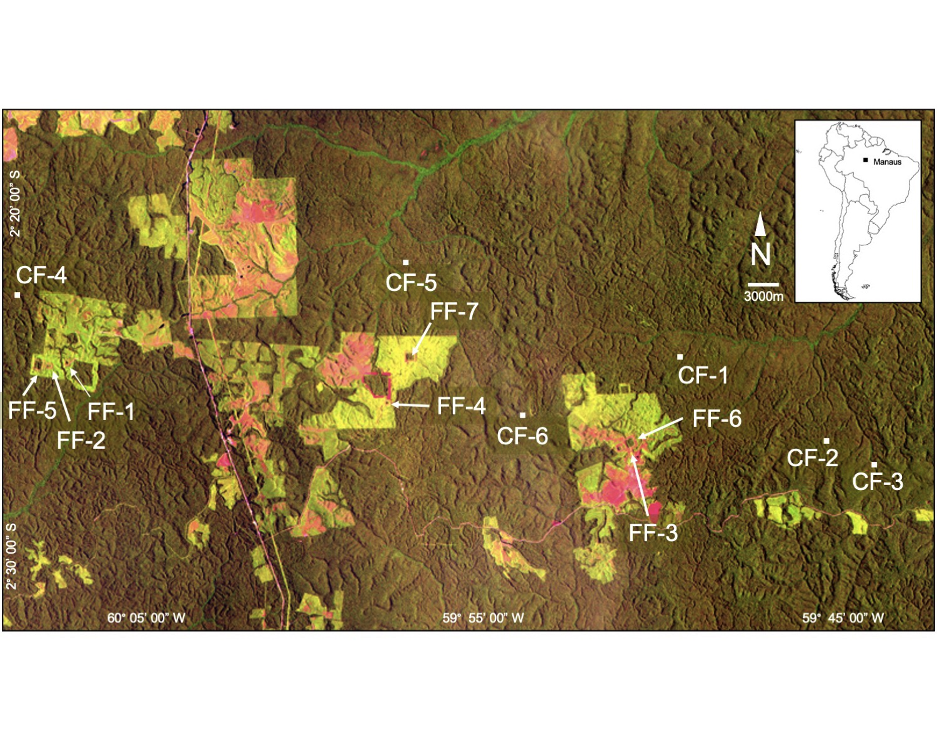

Figure1: Satellite image of the Biological Dynamics of Forest Fragments Project (ca. 1995) showing the location of the Demographic Plots. Plots are located in Continuous Forest (CF1-CF6) or Forest Fragments (FF1-FF7), both of which are dark green. Light green areas are regenerating forest, while red indicates pasture. The BDFFP is located ~70 km north of Manaus, Brazil (inset map). For additional details on each plot see Table 1.

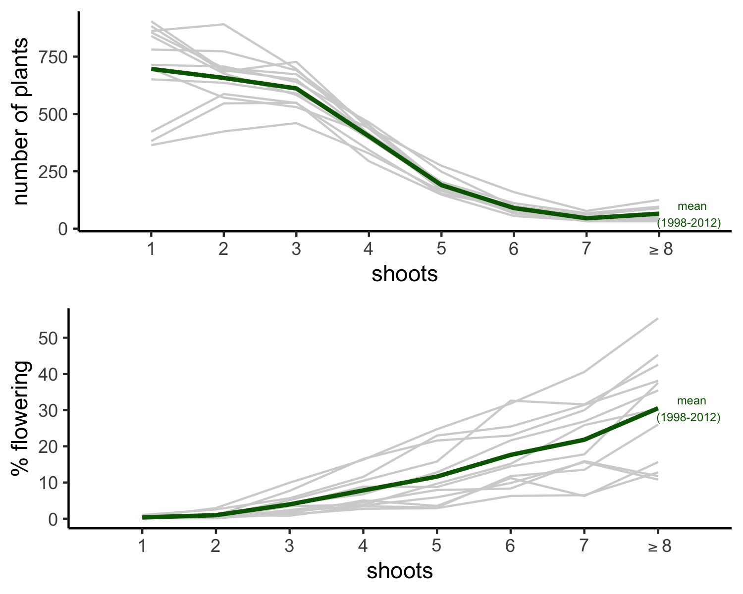

Figure2: The abundance and reproduction of in Continuous Forest. In each of survey year (gray lines) the data from the six demographic plots in Continuous Forest were pooled to give (A) the total number of post-seedling in size classes based on shoot number, and (B) the percentage of plants in each size class that produced at least 1 inflorescence. The green line is the average of the annual values for each size category.

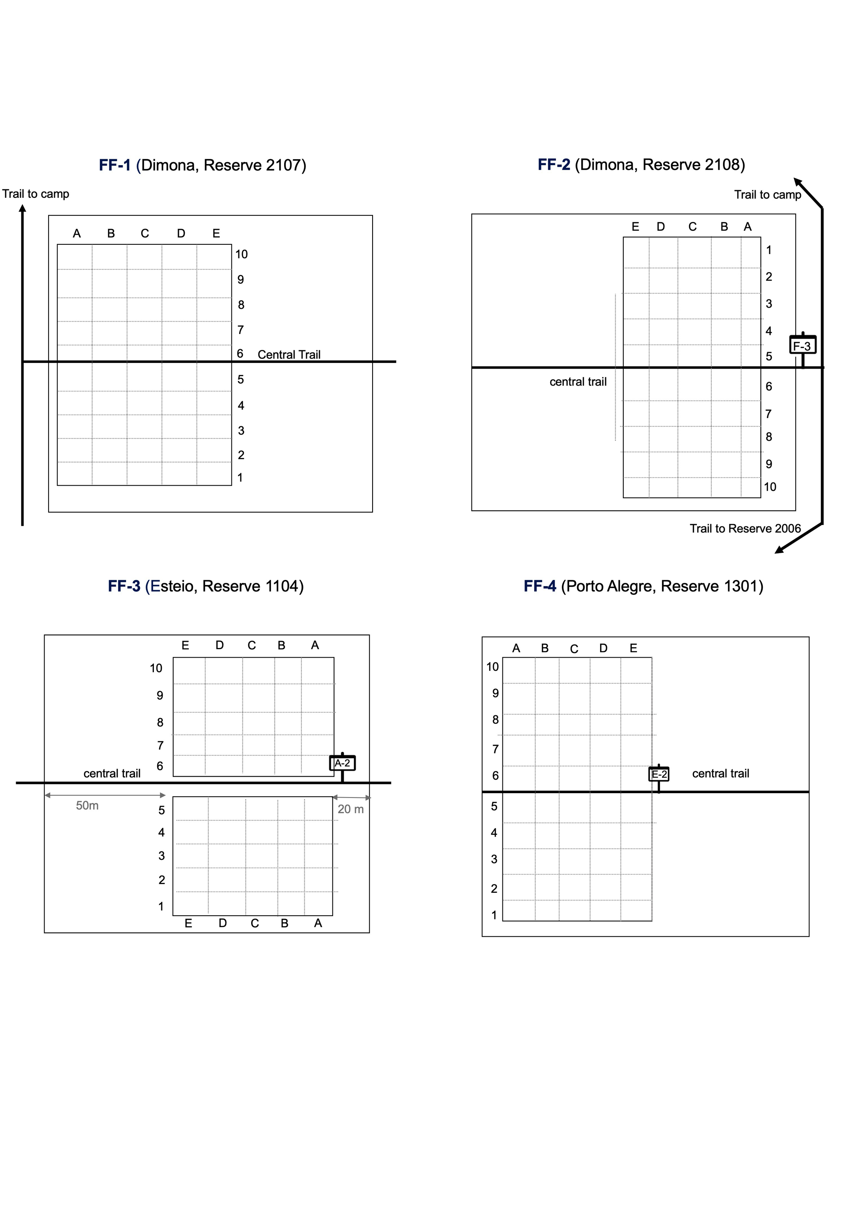

Figure3: Schematic of the Demographic Plots in the BDFFP 1-hectare forest fragment reserves (note: not to scale). The rectangles filled with a letter-number combination (i.e., F-3, A-2, E-2) are coordinate stakes marking the permanent plots of the BDFFP Phytodemographic Project (Rankin-de-Mérona et al. 1992).

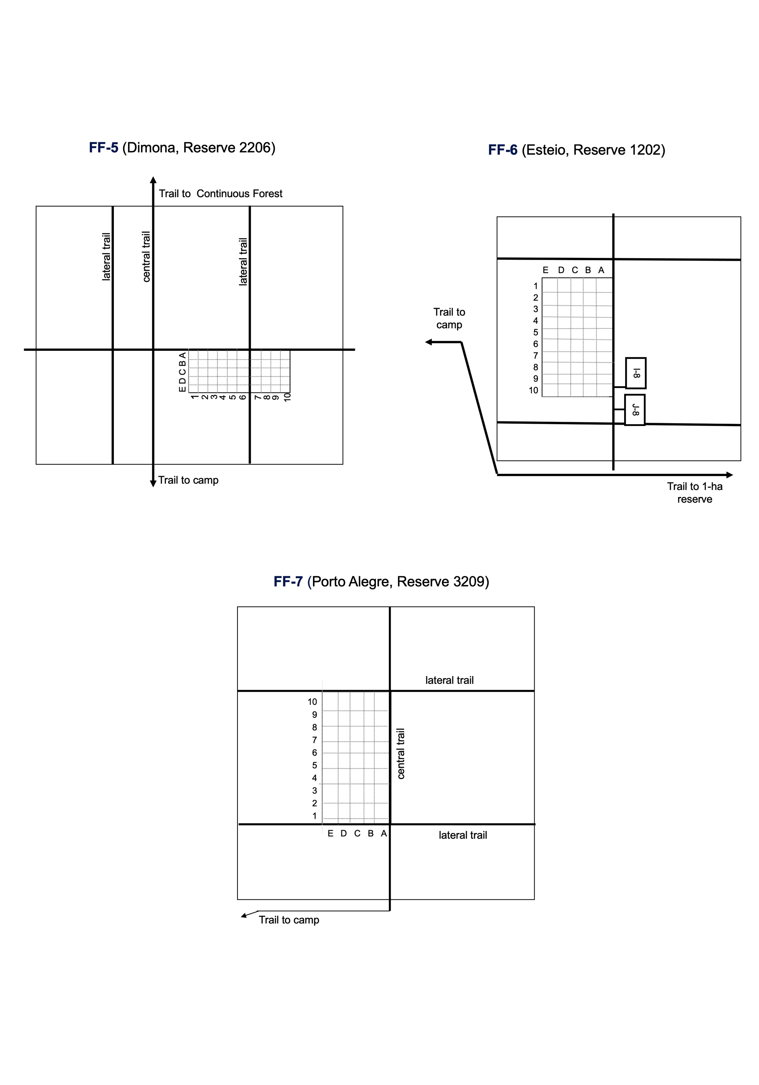

Figure4: Schematic of the Demographic Plots in the BDFFP 10-ha forest fragment reserves (note: not to scale). The rectangles filled with a letter-number combination (i.e., I-8, J-8) are coordinate stakes marking the permanent plots of the BDFFP Phytodemographic Project (Rankin-de-Mérona et al. 1992).

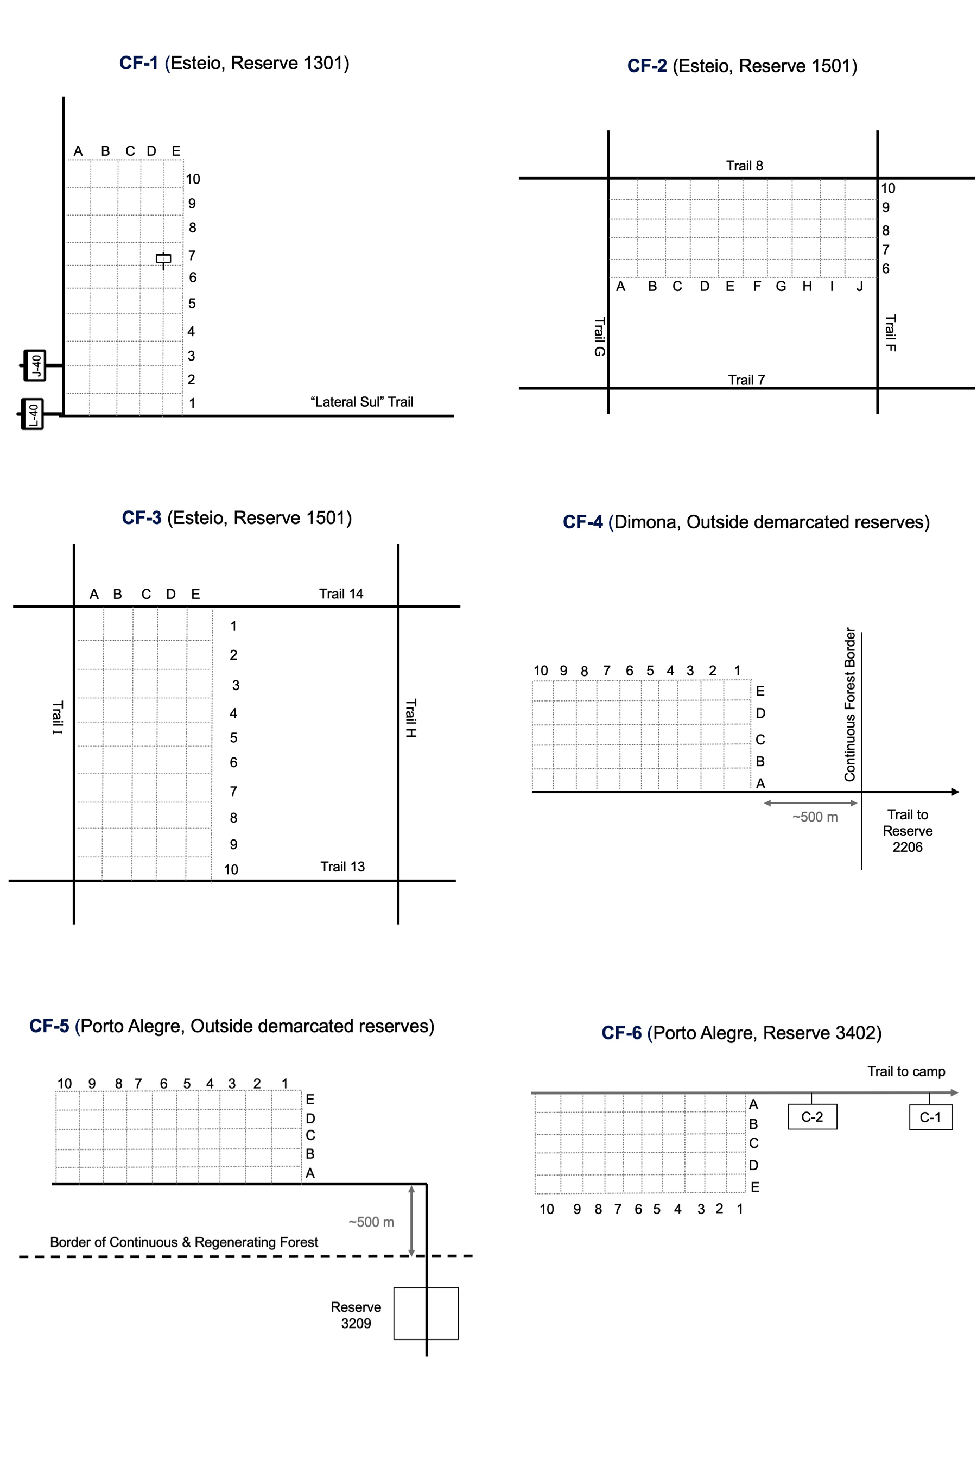

**Table 1**. Variable Information for “Data set File 1: *Descriptors of demographic plots*”.

**Table 2**. Variable Information for “Data set File 2: *Heliconia Demographic Data*”.